Project Design Phase-II Technology Stack (Architecture & Stack)

Date | 7 November 2025
Team ID | NM2025TMID09184
Project Name | Laptop Request Catalog Item
Maximum Marks | 4 Marks

Technical Architecture:
The deliverable includes the architectural diagram and supporting details in Table 1 and Table 2.
This architecture represents how the Laptop Request Catalog Item in ServiceNow enables employees to request laptops efficiently through an automated workflow.
Example: Laptop Request Catalog Item

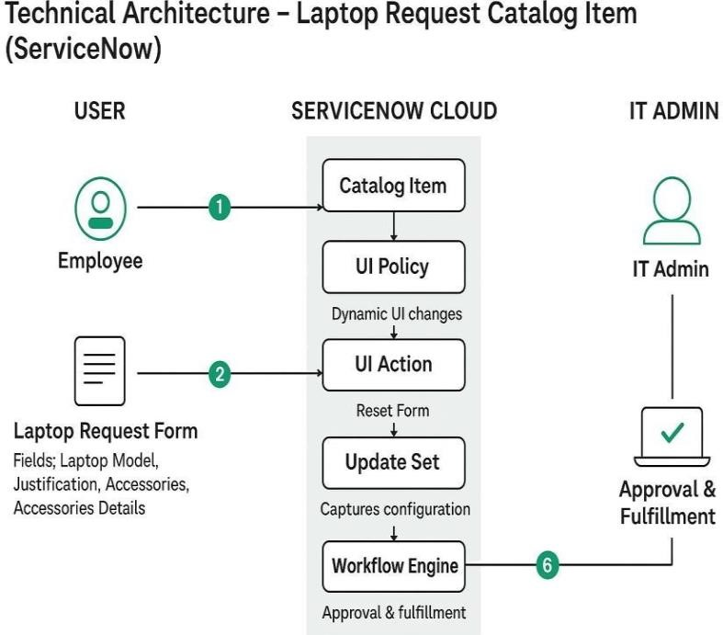 | Guidelines:  - Include all ServiceNow processes (catalog item creation, UI policy, UI action, update set).  - Show infrastructure separation — Local Instance and Cloud Instance.  - Indicate external interfaces (email approvals, notifications).  - Highlight data storage in the ServiceNow database.  - Represent automation scripts for dynamic form behavior.  - Show deployment flow of update sets between instances.

Table 1: Components & Technologies

S.No | Component | Description | Technology
1 | User Interface | Employees request laptops via Service Catalog form. | ServiceNow Service Catalog UI
2 | Application Logic -  1 | Catalog item creation with defined variables. | ServiceNow Catalog Item Form
3 | Application Logic -  2 | Dynamic behavior to show/hide fields based on user input. | Catalog UI Policy
4 | Application Logic -  3 | “Reset Form” functionality implemented using client script. | ServiceNow UI Action
5 | Database | Stores catalog item configurations and variable values. | ServiceNow Tables
6 | Cloud Database | Data stored and managed securely in ServiceNow cloud. | ServiceNow Cloud Database
7 | File Storage | Update set and configuration stored in ServiceNow instance. | System Update Sets
8 | External API  (Optional) | Integration for hardware asset inventory (if required). | REST API Integration
9 | Update Migration | Migrate update set across instances. | XML Export/Import
10 | Infrastructure  (Server/Cloud) | Entire system hosted and managed on ServiceNow SaaS. | ServiceNow Cloud (SaaS)

Table-2: Application Characteristics:

S.No Characteristics Description Technology

- Open-Source Not applicable, as ServiceNow is a proprietary low-code platform. – Frameworks

- Security Role-based access ensures only authorized users can create, Role-Based Access Control Implementations approve, or manage laptop requests. (RBAC), ACLs

- Scalable Architecture Built on ServiceNow’s SaaS model, allowing easy scalability ServiceNow Cloud Architecture across departments and instances.

- Availability Always accessible via the ServiceNow cloud, ensuring 24/7 Load-balanced ServiceNow
uptime and redundancy. Instances
- Performance Efficient performance through optimized catalog forms, client GlideRecord, Service Catalog scripts, and indexed data tables. Optimization

